
Dear Parents:

Head lice can occur at all social and economic levels and are not related to uncleanliness. The most common symptom of head lice is intense itching on the back of the head or neck. They do not jump or fly and do not live on pets.

PLEASE CHECK YOUR CHILD’S HEAD TODAY and THEN ONCE A WEEK. If your child does have head lice, don’t panic. Millions of school children contract head lice each year. Children play in close contact with each other. A simple exchange of hats, clothing, brushes, combs, and other personal articles can result in transmission from one child to another.

To help with parents working to eliminate head lice, we’ve put together this easy-to-follow instruction sheet. It isn’t an absolute guarantee but your odds of success go way up…

IF YOU FOLLOW EVERY STEP LISTED BELOW!

TAKE A DEEP BREATH, READ THIS ALL THE WAY THROUGH ONCE OR TWICE BEFORE YOU BEGIN…..

THESE SHOULD ALL BE DONE ON THE FIRST DAY

- 1. CHECK EVERYONE in the family. Lice are small grayish-tan wingless insects that lay eggs called nits. Nits are tightly glued to the hairs close to the scalp. They are small specks which are glued by the lice onto the hair shaft. They don’t easily just brush off. They must be pulled off or combed out. The nits closest to the scalp are the ones with live eggs in the shell.

- 2. Apply the lice shampoo to DRY hair of all infested family members, follow instructions carefully.

3. After shampooing, REMOVE ALL THE NITS with a good metal nit comb. THIS TAKES TIME. BE PATIENT

- 4. WASH sheets, pillowcases and clothing IN HOT WATER (at least 20 minutes).

- 5. UNWASHABLES (put through hot dryer for 20 minutes: blankets, bedspreads, hats, hair bows, backpacks & sleeping bags) or seal in a plastic trash bag for at least two weeks.

- 6. Bike helmets, head phones, stuffed animals should be PUT IN PLASTIC BAGS and tied for 14 days.

- 7. Soak combs, brushes, head bands, barrettes in the hot water for at least 10 minutes or in dishwasher.

THESE SHOULD BE DONE EVERY DAY FOR ONE WEEK

8. Check heads EVERY NIGHT FOR ONE WEEK and removes any nits that were missed on Day 1, 2, 3, etc

9. Remember to SHAMPOO AGAIN in 7or 8 days so you catch any missed nits that may have hatched…
Mark your calendar NOW !

HINTS FOR THE EASIEST PROCESS –

After you’ve check all the heads and know which beds, linens and belongings need attention
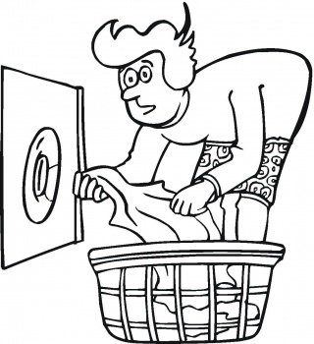
- START WITH THE ENVIRONMENT:
- Bag up the unwashables, seal the bag. Put it where your child can’t get back into it..
- Strip the beds and start the wash of all the items you can wash
- Put the unwashables in the drier
- Start soaking the headbands, brushes combs, etc in boiled water

- WORK ON THE LICE ON THE HEAD while the laundry is doing its thing
- Massage in store-bought lice killing shampoo into dry hair. Work especially into the roots near the scalp.
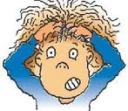
- Let it sit for 10-15 minutes (per the instructions on the box)
- Rinse out all the dead lice
- Apply any conditioner and leave in for the combing process
- Some find that vinegar solutions help loosen the nit glue… try it if you like it.

- GET RID OF THE NITS: THIS IS THE MOST EFFECTIVE WAY TO BEAT LICE !
- Pick out a good long movie, video game or computer game to keep them still
- Spread a sheet on the floor
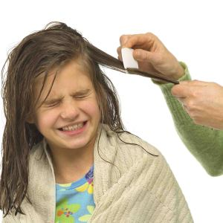
- Turn on all the lights so you can really see what you’re doing
- Put a short chair on the sheet for your child, with a tall chair behind it for you.
- Cover their shoulders with a towel
- Using the special head lice comb from the shampoo box, comb tiny little sections in an orderly method. Clip all the hair up on top and work from bottom to top, from front to back
- Using hair clips to keep the hair up out of your way helps tremendously
- Wipe the nits on the towel or dip comb in a large bowl of water as you go.
- Wash hair with regular shampoo.

- RECHECK EVERY NIGHT FOR A WEEK - THEN - RE-SHAMPOO ONE MORE TIME ON DAY 7or 8
IF YOU FIND LIVE LICE, YOU HAVE TO START ALL OVER FROM THE BEGINNING.

- If you’re still not sure, check out the internet for a good video tutorial on how to comb out the nits

- CALL FRIENDS AND FAMILIES THAT MIGHT HAVE BEEN EXPOSED…

Have they had sleep-overs, are they on a team, do they take group lessons anywhere, do they carpool with others, have they been babysitting, did they borrow someone’s comb, hair bows, headphones or hoodie?

If every head gets cleaned at the same time, you have a better chance of not getting it back.

Day 1 Day 2 Day 3 Day 4 Day 5 Day 6 Day 7 or 8
Laundry
Shampoo
Combing
Head check

Comb again if needed
Head check

Comb again if needed

Head check

Comb again if needed

Head check

Comb again if needed

Head check

Comb again if needed

Shampoo

